**Name:** JAYASURYA C  
**Department:** B.Tech Information Technology  
**Course:** Operating Systems  
**Course Code:** CSA0403  
**Experiment No.:** 8

Construct a C program to simulate Round Robin scheduling algorithm with C.

### ****AIM****

The aim of this program is to implement **CPU Scheduling using the Round Robin (RR) algorithm**, where each process is executed for a fixed **time quantum** in a cyclic order until all processes are completed.

### ****ALGORITHM****

Start the program.

Input the number of processes, their **Arrival Time (AT)**, **Burst Time (BT)**, and the **Time Quantum (TQ)**.

Initialize a ready queue to store processes in waiting order.

At the current time, select the process at the front of the queue and execute it for:

**TQ units**, if remaining burst time > TQ.

**Remaining burst time**, if less than or equal to TQ.

If the process is not finished, push it back into the ready queue with updated remaining time.

If the process completes, record:

**Completion Time (CT)**

**Turnaround Time (TAT) = CT – AT**

**Waiting Time (WT) = TAT – BT**

Repeat until all processes are completed.

Display AT, BT, CT, TAT, and WT for each process.

Compute and display **average WT** and **average TAT**.

End the program.

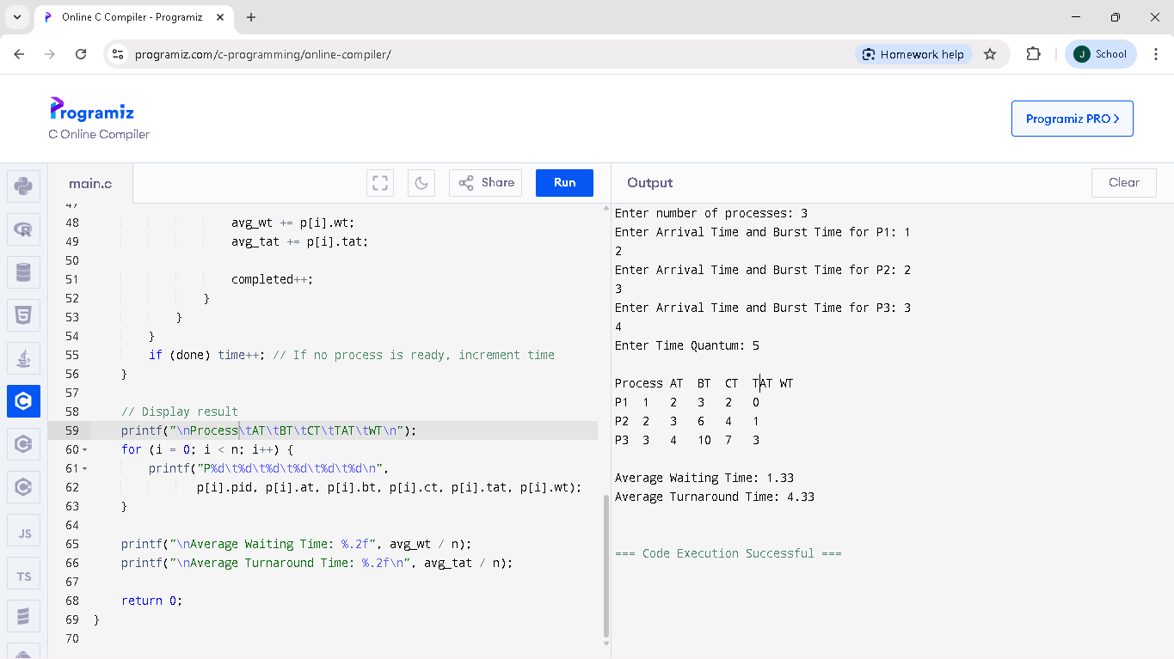PROGRAM AND OUTPUT: